- Nithin T –

2 Panellists were there at the time of Interview.
HTML, CSS – Asked more questions and their expectation was more on basic concepts.

React –
Asked theory questions and asked on projects especially scenario based questions.
Formica – used for the input validation and they asked completes steps in the same.
Asked about life cycle method – and answered well.
Problem solving skill set – by giving the scenario and asked to explain using pen and paper. Asked to do a task - design a To Do list – On click the add button the input field should increment in the same due, on the click of the delete button the field should delete.

Life cycle methods – explain
Difference b/w functional components and class components difference
Favorite project in the resume – Explain in detail
What was the difficult task in any project in the resume? Asked to explain it.
HTML – Semantic and non-Semantic tags.
What is - Inline tags
What is - Block tags
Hoe to get a container or box to the mid position of the screen.
What is grid system and explain in detail.
What is Flex Box and how different it is with grid system
Explain position properties.

Feedback – Explained theory questions.
Explained scenarios properly.
Would have explained better and needed proper preparation.

- Shuvam Mohapatra -
2 Panellists were there at the time of Interview. 1 is React developer and 1 more probably TL.
They went through the CV and started questions on projects in detail – asked what are the packages, dependencies and roles and responsibilities in the project.
If full stack developer – how many months worked in BE and FE.
How comfortable you are in working with BE and FE and how much you want to rate yourself on FE and BE.
HTML, CSS – went in depth and should have clear cut understanding of CSS.
HTML Tags – WRITE DOWN SOME INLINE AND BLOCK LEVEL TAGS.
Table structure
Tags in details. Write everything in pen and paper.

CSS – RWD – You should know different ways to make a page responsive. Explain in details.
Media Queries – Write in a paper
Flex Box and Grid System in details
CSS Box Model Questions. Know all the properties and write in paper. Individual properties like padding – 4 values, 3 values, 2 values, 1 value – You should know how to write them

Position Properties in details.

The panelist will give a viewport and some boxes. Will ask you to position them on the white board.
Small properties like colors, borders, box shadow, border radius etc. – You should know the syntax and write them on a paper.
Bootstrap Classes – details
Tailwind CSS if mentioned

REACT –
How much confident are you in React out of 10?
What all have you designed/build in react?
Have you worked in class based components?
If yes he will ask lifecycle methods.
If no, hooks?
Hooks in details. And write the syntax on paper.
Then he will ask you what hooks have you worked on.
Then he will give a code snippet and ask the output – regarding hooks.
JWT – Where can you store Tokens in client’s side? All the methods.
How can you pass token through Axios.
Write the code for Axios in pen paper.
Call and API and populate the data using Axios.
Promises – Async/Await in details.
JS Closures.

Difficulties you faced in project?

The panelist gave a nested JSON data. Arrays of objects. Asked to fetch a particular name from the data. Write the code in paper-pen.
Difference between null and undefined.

Round 2
Coding round
The panelist will show their screen having a live page. The page will have many functionalities. They will explain you the requirements and ask you the time you require to complete it. [Think and give the time]. Time constraint will be a problem. They focus more on the functionality part. The coding Standards are to be followed.

Feedback –
Everything went well and answered all the questions. But in 2nd round I have asked for 1 hour to complete the task and there were 2 bugs and they gave me 30 minutes to remove the bugs and done it. But taken time more than 1 hour and that’s the reason they haven’t considered.
- Pramod Jawalkar M –
Round 1:
- Basic display property in css, how many ways to make a box in center
- When do we use Display flex and display grid
- Given a task on display flex , how do we align at corner of screen
- Expain your project ,(I had mentiones bootstrap css, tailwind css, Chakra Ui) they asked me which is good and why
- What is Html semantic tags and normal tags
- What is difference between set timeout and set interval
- What is event deligation

Round 2:
- They had given an Array of Object and asked to filter out “name” which is starting with alphabet “a”, only includes single alphablet “a”(without using in build array method)
- React basic hooks that I have used in the project
- What is virtual Dom , normal flow of react
- Did you create any custom hooks in your project
- What is Redux have you worked on redux
- Can you explain the modules you have worked in your project

Round – 3
The panelist will show their screen having a live page. The page will have many functionalities. They will explain you the requirements and ask you the time you require to complete it. [Think and give the time]. Time constraint will be a problem. They focus more on the functionality part. The coding Standards are to be followed.

Feedback –
Would have more focused on Coding and would have revised once.
Shouldn’t have used Vanilla CSS, would have used tailwind CSS or Bootstrap so that task would have completed in time. Received the partial out-put. Took 2 hours to complete the task.

- Busetty Sujith Kumar –

• Introduce yourself
• Write HTML5 structure?
• Arrange 3 divs using html css in below manner

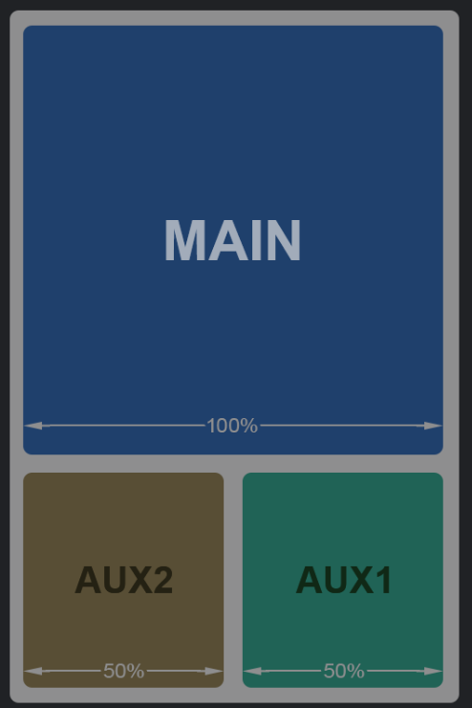

• Centre the div using html and css
• Difference between height 100% and height: 100vh
• Explain about flex-box concept in css3?
• What is difference between flex-box and grid system in css3?
• Tell me about your last project
• What is redux. And explain flow of redux?
• List some of ES6 features of javascript and explain them?
• What are promises? And explain about promise.all(),
• race(), allSettled().
• What is next js. And why we prefer next js over react js.
• Explain how you implemented payment way integration in your project?

Feedback –

Project explanation would have been better.
Answered everything in theory.
Need to improve in explaining project flow.

